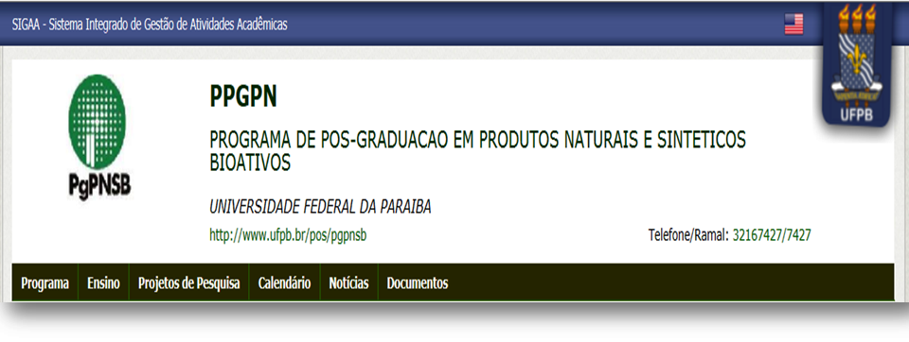
SciForum
MOL2NET

Title of the paper
Firstname Lastname ^{1,}*, Firstname Lastname ² , Firstname Lastname ³ and
Firstname Lastname ⁴
¹ Full Affiliation, Address; E-Mail: author2@email
² Full Affiliation, Address; E-Mails: author3@email (F.L.); author4@email (F.L.);
* Author to whom correspondence should be addressed; E-Mail: author1@email;
Tel.: +1-111-111-111 (ext. 123); Fax: +1-111-111-112.

Received: / Accepted: / Published:

Abstract: This is the abstract section in English (mandatory). One paragraph only (Maximum 300 words approx.).
.
.
.

.
.
.
.
.

Keywords: keyword; keyword; keyword (3–10 keywords separated by semi colons)

Mol2Net YouTube channel: http://bit.do/mol2net-tube
YouTube link: please, paste here the link to your personal YouTube video, if any.

1. Introduction

Main text paragraph.
.
.
.
.
.
.
.
.
.
.
.
.
.
.
.
Main text paragraph.
.
.
.
.
.
.
.
.
.
.
.
.
.
.
2. Results and Discussion

Main text paragraph.
.
.
.
.
.
.
.
.
.
Main text paragraph.
.
.
.
.
.
.
.
.
.

Table 1. Add a descriptive label of the table here.
[add the table here]

[add the figure here]
Figure 1. Add a descriptive label of the figure here

3. Materials and Methods

Main text paragraph.
.
.
.
.
.
.
.
.
.
.
.
.
.
.
.
.
.
.
.
.
.
.
.
.
.
.
.
.
.
.
.
Main text paragraph.
.
.
.
.
.
.
.
.
.
.
4. Conclusions

Main text paragraph.
.
.
.
.
.
.
.
.
.
Main text paragraph.
.
.
.
.
.
.
.
.

Acknowledgments
Main text paragraph.
.
.
.
.
.

Author Contributions
Main text paragraph.
Conflicts of Interest
State any potential conflicts of interest here or “The authors declare no conflict of interest”.
References and Notes
- Author 1, A.B.; Author 2, C.D. Title of the cited article. Journal Title 2007, 6, 100–110.
- Author 1, A.; Author 2, B. Title of the chapter. In Book Title, 2nd ed.; Editor 1, Editor 2, Eds.; Publisher: Publisher Location, Country, 2007; Volume 3, pp. 154–196.
- Author 1, A.; Author 2, B. Book Title, 3rd ed.; Publisher: Publisher Location, Country, 2008;
pp. 154–196.
- Author 1, A.B.; Author 2, C. Title of Unpublished Work. Journal Abbreviation, phrase indicating stage of publication.
- Author 1, A.B.; Author 2, C.D.; Author 3, E.F. Title of Presentation. In Title of the Collected Work (if available), Proceedings of the Name of the Conference, Location of Conference, Country, Date of Conference; Editor 1, Editor 2, Eds. (if available); Publisher: City, Country, Year (if available); Abstract Number (optional), Pagination (optional).
- Author 1, A.B. Title of Thesis. Level of Thesis, Degree-Granting University, Location of University, Date of Completion.
- Author 1, A.B.; Author 2, C.D. Title of the article. Abbreviated Journal Name, Year, Volume, (Page range), doi or other identification number. Available online: http://URL (accessed on Day Month Year).
- Title of Site. Available online: http://URL (accessed on Day Month Year).

Notes:

MDPI do not released one specific template for Sciforum conference. Consequentyl, this is not official template released by MDPI. In principle, the papers may be presented without specific format. However, the chairperson and the secretariat of the conference decided to create this template to give homogeneity to Mol2Net works. As is, this template should be used only for Mol2Net conference. Please, do not use this template for MDPI journals. Please, delete these notes before saving your final version. Type of the Paper (Proceeding, Letter, Expert Opinion, Communication, etc.). MDPI generates doi upon author request.

YouTube link: this option is only for those authors with welcome videos and/or oral presentations, plenary conferences uploaded to Mol2Net YouTube site.
Reference list: We recommend the use of reference management software to prepare the references list (e.g., Endnote, http://endnote.com/styles/MDPI.ens ).
© 2015 by the authors; licensee MDPI, Basel, Switzerland. This article is an open access article distributed under the terms and conditions defined by MDPI AG, the publisher of the Sciforum.net platform. Sciforum papers authors the copyright to their scholarly works. Hence, by submitting a paper to this conference, you retain the copyright, but you grant MDPI AG the non-exclusive and un-revocable license right to publish this paper online on the Sciforum.net platform. This means you can easily submit your paper to any scientific journal at a later stage and transfer the copyright to its publisher (if required by that publisher). (http://sciforum.net/about ).

